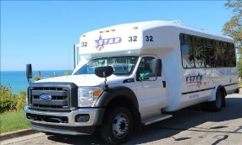
TRANSPORTATION

Van Buren Public Transit (STAR) offers many services:
(269) 427-7921 or (800) 828-2015

Monday-Friday: 6:00am-7:30pm, Saturday and Sunday: 10:00am-4:00pm

FLEX LOOP ROUTES: This route keeps to a regular hourly schedule, but vehicles can deviate from the route to pick-up or drop off passengers from other locations along the way, when prearranged through Dispatch.
South Haven Loop Hours of Operation: Monday -Friday 9:00 to 5:00 p.m./4:00 p.m. last loop. Saturday & Sunday 10:00 a.m. - 4:00 p.m./3:00 p.m. last loop.

DIAL-A-RIDE: Curb to curb service within the South Haven area.
Hours of Operation: Monday – Friday 6:45 to 8:00 p.m./7:30 p.m. last call

VETERANS SHUTTLE: Veterans travel to the VA Medical Center in Battle Creek.
Hours of Operation: Tuesday – Thursday: Drop off: 9:00 a.m. & 12:30 p.m.
Returns: 12:30 p.m. & 4:30 p.m.

RESERVATIONS-IN COUNTY: Travel within Van Buren County. We recommend at least 24 hours advance notice for reservation rides. Reservations can be made up to 14 days in advance.
RESERVATIONS-OUT OF COUNTY: Travel to surrounding area counties for medical
appointments. Reservations can be made up to 14 days in advance.

Hours of Operation: Monday – Friday: Pick-up 8:45 a.m. to 9:45 a.m.
Return 12:00 p.m. to 12:30 p.m.
Pick-up 12:00 p.m. to 1:00 p.m.
Return 4:30 p.m. to 5:00 p.m.

Wheelchair lifts available in advance

